**STATS 295: Bayes-I**

**Ankoor Bhagat**

**UCI ID: 92963676**

***Homework # 4***

2,3,5,10,14,17 (these are all simple variations of analyses of the o-ring data.)  
4,11,18,19  (these are all variations of analyses of the trauma data)  
21  (this is cow abortion data with random effects)

***Exercise 8.2***

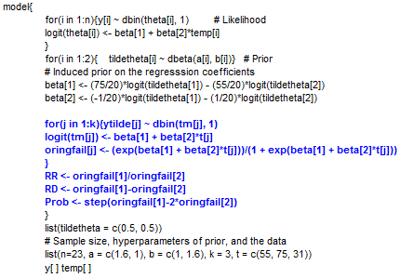

**(1)**

**Point estimate and P.I. for the ratio and the difference b/w probabilities of O-ring failures at 55 and 75 degrees**

|  |  |  |  |  |  |  |  |  |
| --- | --- | --- | --- | --- | --- | --- | --- | --- |
| **node** | **mean** | **sd** | **MC error** | **2.50%** | **median** | **97.50%** | **start** | **sample** |
| RD (P55 - P75) | 0.5388 | 0.2091 | 0.001255 | 0.0996 | 0.5568 | 0.8844 | 501 | 99500 |
| RR (P55 / P75) | 6.44 | 6.783 | 0.03854 | 1.378 | 4.615 | 22.65 | 501 | 99500 |

**(2)**

**Posterior prob. that prob. of failure at 55 degrees is at least double the corresponding prob. at 75 degrees**

|  |  |  |  |  |  |  |  |  |
| --- | --- | --- | --- | --- | --- | --- | --- | --- |
| **node** | **mean** | **sd** | **MC error** | **2.50%** | **median** | **97.50%** | **start** | **sample** |
| P55 = 2*P75 | 0.9105 | 0.2855 | 0.001391 | 0 | 1 | 1 | 501 | 99500 |

**(3)**

**Probability of O-ring failure at 31 degrees**

|  |  |  |  |  |  |  |  |  |
| --- | --- | --- | --- | --- | --- | --- | --- | --- |
| **node** | **mean** | **sd** | **MC error** | **2.50%** | **median** | **97.50%** | **start** | **sample** |
| P31 | 0.9312 | 0.1325 | 7.15E-04 | 0.4934 | 0.9857 | 1 | 501 | 99500 |
| Y31 | 0.9298 | 0.2554 | 9.94E-04 | 0 | 1 | 1 | 501 | 99500 |

***Exercise 8.3***

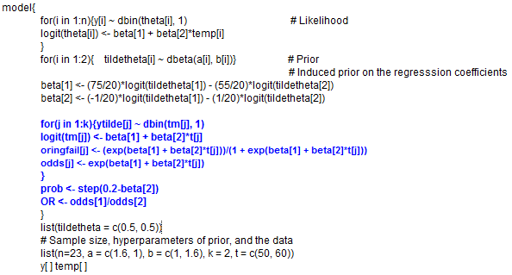

**Predictive probability of at least one O-ring failure at 50 and 60 degrees respectively**

|  |  |  |  |  |  |  |  |  |
| --- | --- | --- | --- | --- | --- | --- | --- | --- |
| **node** | **mean** | **sd** | **MC error** | **2.50%** | **median** | **97.50%** | **start** | **sample** |
| P50 | 0.791 | 0.1747 | 9.66E-04 | 0.351 | 0.8403 | 0.9903 | 501 | 99500 |
| P60 | 0.5717 | 0.1621 | 7.04E-04 | 0.2578 | 0.574 | 0.8697 | 501 | 99500 |

**Posterior probability that β2 < -0.2**

|  |  |  |  |  |  |  |  |  |
| --- | --- | --- | --- | --- | --- | --- | --- | --- |
| **node** | **mean** | **sd** | **MC error** | **2.50%** | **median** | **97.50%** | **start** | **sample** |
| P(β2) < -0.2 | 1 | 0 | 3.17E-13 | 1 | 1 | 1 | 501 | 99500 |

**Point and interval inference for the proportion of shuttles with O-ring failures at 50 and 60 degrees**

|  |  |  |  |  |  |  |  |  |
| --- | --- | --- | --- | --- | --- | --- | --- | --- |
| **node** | **mean** | **sd** | **MC error** | **2.50%** | **median** | **97.50%** | **start** | **sample** |
| Y50 | 0.7909 | 0.4066 | 0.00153 | 0 | 1 | 1 | 501 | 99500 |
| Y60 | 0.5729 | 0.4947 | 0.001868 | 0 | 1 | 1 | 501 | 99500 |

**Odds and Odds Ratio**

|  |  |  |  |  |  |  |  |  |
| --- | --- | --- | --- | --- | --- | --- | --- | --- |
| **node** | **mean** | **sd** | **MC error** | **2.50%** | **median** | **97.50%** | **start** | **sample** |
| OR[50/60] | 5.398 | 5.696 | 0.03194 | 1.263 | 3.912 | 18.72 | 501 | 99500 |
| odds[50] | 18.32 | 139.2 | 0.4769 | 0.5409 | 5.261 | 101.6 | 501 | 99500 |
| odds[60] | 1.888 | 1.989 | 0.007677 | 0.3473 | 1.348 | 6.674 | 501 | 99500 |

***Exercise 8.4***

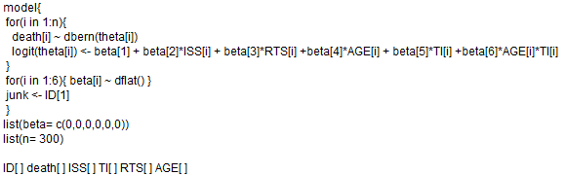

**Results from running the code given in the book:**

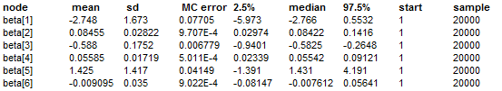

**Results given in the book:**

|  |  |
| --- | --- |
| **Variable** | **Mean** |
| Intercept - (β1) | -2.708 |
| ISS - (β2) | 0.085 |
| RTS - (β3) | -0.595 |
| AGE - (β4) | 0.056 |
| TI - (β5) | 1.409 |
| AGE*TI - (β6) | -0.008 |

***The results from running the code are very similar to the results given in the book.***

**Covariate vectors**: ***Vector 1*.** (ISS, RTS, AGE, TI) = (25, 5, 50, 1); ***Vector 2.*** (ISS, RTS, AGE, TI) = (50, 5, 50, 0)

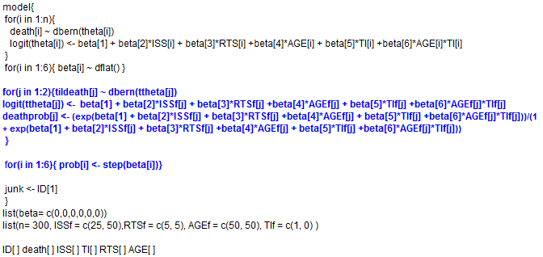

**Predictive probabilities of death for the covariate vector 1 and 2**

|  |  |  |  |  |  |  |  |  |
| --- | --- | --- | --- | --- | --- | --- | --- | --- |
| **node** | **mean** | **sd** | **MC error** | **2.50%** | **median** | **97.50%** | **start** | **sample** |
| deathprob[1] | 0.5425 | 0.1958 | 0.002857 | 0.1484 | 0.5554 | 0.8738 | 1 | 20000 |
| deathprob[2] | 0.7731 | 0.1275 | 0.002942 | 0.4706 | 0.7972 | 0.9514 | 1 | 20000 |

**Posterior probability that each of βj is non-negative**

|  |  |  |  |  |  |  |  |  |  |
| --- | --- | --- | --- | --- | --- | --- | --- | --- | --- |
| node | Probability | mean | sd | MC error | 2.50% | median | 97.50% | start | sample |
| prob[1] | Pr(β1) > 0 | 0.0399 | 0.1957 | 0.006145 | 0 | 0 | 1 | 1 | 20000 |
| prob[2] | Pr(β2) > 0 | 0.999 | 0.03239 | 2.82E-04 | 1 | 1 | 1 | 1 | 20000 |
| prob[3] | Pr(β3) > 0 | 1.00E-04 | 0.009999 | 9.96E-05 | 0 | 0 | 0 | 1 | 20000 |
| prob[4] | Pr(β4) > 0 | 0.9998 | 0.01581 | 1.31E-04 | 1 | 1 | 1 | 1 | 20000 |
| prob[5] | Pr(β5) > 0 | 0.8615 | 0.3454 | 0.006717 | 0 | 1 | 1 | 1 | 20000 |
| prob[6] | Pr(β6) > 0 | 0.3823 | 0.4859 | 0.009832 | 0 | 0 | 1 | 1 | 20000 |

**Point and interval inferences for the proportion of deaths at two covariate combinations**

|  |  |  |  |  |  |  |  |  |
| --- | --- | --- | --- | --- | --- | --- | --- | --- |
| **node** | **mean** | **sd** | **MC error** | **2.50%** | **median** | **97.50%** | **start** | **sample** |
| tildeath[1] | 0.5436 | 0.4981 | 0.004683 | 0 | 1 | 1 | 1 | 20000 |
| tildeath[2] | 0.7686 | 0.4217 | 0.00407 | 0 | 1 | 1 | 1 | 20000 |

***Exercise 8.5***

Inferences for temperature at which 5% of flights would experience O-ring failures

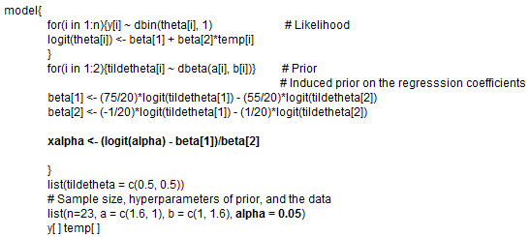

Results:



***Exercise 8.10***

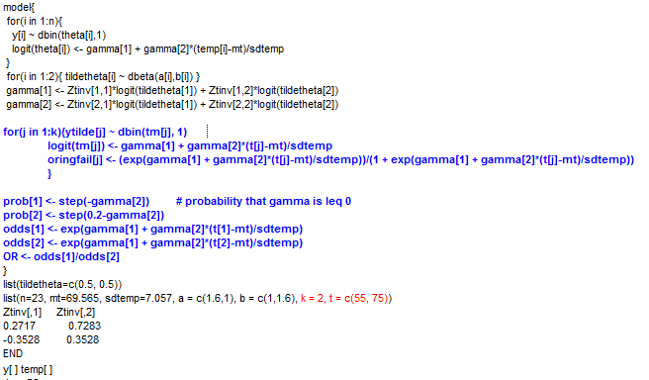

**Inferences about parameters gamma[i] and tildetheta[i], i = 1, 2**

|  |  |  |  |  |  |  |  |  |
| --- | --- | --- | --- | --- | --- | --- | --- | --- |
| **node** | **mean** | **sd** | **MC error** | **2.50%** | **median** | **97.50%** | **start** | **sample** |
| gamma[1] | -1 | 0.5045 | 0.001677 | -2.058 | -0.977 | -0.07075 | 501 | 99500 |
| gamma[2] | -1.195 | 0.4967 | 0.002084 | -2.268 | -1.163 | -0.316 | 501 | 99500 |
| tildetheta[1] | 0.7734 | 0.1487 | 6.27E-04 | 0.4201 | 0.8028 | 0.9738 | 501 | 99500 |
| tildetheta[2] | 0.1475 | 0.08228 | 3.32E-04 | 0.03053 | 0.1329 | 0.3422 | 501 | 99500 |

**Posterior probability that γ2 < 0 and γ2 < -0.2**

|  |  |  |  |  |  |  |  |  |
| --- | --- | --- | --- | --- | --- | --- | --- | --- |
| **node** | **mean** | **sd** | **MC error** | **2.50%** | **median** | **97.50%** | **start** | **sample** |
| P(γ2) < 0 | 0.9974 | 0.05105 | 1.74E-04 | 1 | 1 | 1 | 501 | 99500 |
| P(γ2) < -0.2 | 0.9996 | 0.02005 | 6.58E-05 | 1 | 1 | 1 | 501 | 99500 |

**Predictive probability of at least one O-ring failure at 50 and 60 degrees respectively**

|  |  |  |  |  |  |  |  |  |
| --- | --- | --- | --- | --- | --- | --- | --- | --- |
| **node** | **mean** | **sd** | **MC error** | **2.50%** | **median** | **97.50%** | **start** | **sample** |
| P55 | 0.7734 | 0.1487 | 6.27E-04 | 0.42 | 0.8028 | 0.9738 | 501 | 99500 |
| P75 | 0.1475 | 0.08228 | 3.32E-04 | 0.03053 | 0.1329 | 0.3422 | 501 | 99500 |

**Odds and Odds Ratio**

|  |  |  |  |  |  |  |  |  |
| --- | --- | --- | --- | --- | --- | --- | --- | --- |
| **node** | **mean** | **sd** | **MC error** | **2.50%** | **median** | **97.50%** | **start** | **sample** |
| OR[55/75] | 116.1 | 2092 | 6.63 | 2.448 | 27.03 | 618.1 | 501 | 99500 |
| odds[55] | 7.918 | 24.83 | 0.08131 | 0.7242 | 4.07 | 37.2 | 501 | 99500 |
| odds[75] | 0.1854 | 0.1312 | 5.39E-04 | 0.03149 | 0.1532 | 0.5202 | 501 | 99500 |

***Results from running Exercise 8.2 again for unstandardized variables:***

|  |  |  |  |  |  |  |  |  |
| --- | --- | --- | --- | --- | --- | --- | --- | --- |
| **node** | **mean** | **sd** | **MC error** | **2.50%** | **median** | **97.50%** | **start** | **sample** |
| P55 | 0.701 | 0.1767 | 8.76E-04 | 0.3098 | 0.7263 | 0.9619 | 501 | 99500 |
| P75 | 0.1622 | 0.08601 | 4.53E-04 | 0.03587 | 0.1483 | 0.3628 | 501 | 99500 |
| beta[1] | 8.823 | 4.64 | 0.02782 | 0.793 | 8.445 | 18.98 | 501 | 99500 |
| beta[2] | -0.1415 | 0.06779 | 4.17E-04 | -0.2905 | -0.136 | -0.02478 | 501 | 99500 |
| tildetheta[1] | 0.885 | 0.1109 | 6.54E-04 | 0.5828 | 0.9206 | 0.9954 | 501 | 99500 |
| tildetheta[2] | 0.5683 | 0.02609 | 1.41E-04 | 0.5217 | 0.5668 | 0.624 | 501 | 99500 |
| OR[55/75] | 65.09 | 2035 | 6.954 | 1.642 | 15.17 | 333.6 | 501 | 99500 |
| odds[55] | 5.21 | 14.34 | 0.05821 | 0.4488 | 2.654 | 25.28 | 501 | 99500 |
| odds[75] | 0.2079 | 0.1416 | 7.24E-04 | 0.03721 | 0.1741 | 0.5694 | 501 | 99500 |
| P(β2) < 0 | 0.9929 | 0.0837 | 3.38E-04 | 1 | 1 | 1 | 501 | 99500 |
| P(β2) < -0.2 | 1 | 0 | 3.17E-13 | 1 | 1 | 1 | 501 | 99500 |

***Exercise 8.11***

**16 different combinations of covariates ISS, RTS, AGE, TI**

|  |  |  |  |  |
| --- | --- | --- | --- | --- |
|  | ISSf | RTSf | AGEf | TIf |
| 1 | 20 | 3.34 | 10 | 0 |
| 2 | 40 | 3.34 | 10 | 0 |
| 3 | 20 | 3.34 | 10 | 1 |
| 4 | 40 | 3.34 | 10 | 1 |
| 5 | 20 | 5.74 | 10 | 0 |
| 6 | 40 | 5.74 | 10 | 0 |
| 7 | 20 | 5.74 | 10 | 1 |
| 8 | 40 | 5.74 | 10 | 1 |
| 9 | 20 | 3.34 | 60 | 0 |
| 10 | 40 | 3.34 | 60 | 0 |
| 11 | 20 | 3.34 | 60 | 1 |
| 12 | 40 | 3.34 | 60 | 1 |
| 13 | 20 | 5.74 | 60 | 0 |
| 14 | 40 | 5.74 | 60 | 0 |
| 15 | 20 | 5.74 | 60 | 1 |
| 16 | 40 | 5.74 | 60 | 1 |

**Transformed case** – 16 possible combinations of (ISS, RTS, AGE, TI) covariates

Results:

**Probability that regression coefficients are positive**

|  |  |  |  |  |  |  |  |  |  |
| --- | --- | --- | --- | --- | --- | --- | --- | --- | --- |
| node | Probability | mean | sd | MC error | 2.50% | median | 97.50% | start | sample |
| prob[1] | Pr(γ1) > 0 | 0 | 0 | 7.16E-13 | 0 | 0 | 0 | 501 | 19500 |
| prob[2] | Pr(γ2) > 0 | 0.9992 | 0.02772 | 4.10E-04 | 1 | 1 | 1 | 501 | 19500 |
| prob[3] | Pr(γ3) > 0 | 5.13E-05 | 0.007161 | 5.13E-05 | 0 | 0 | 0 | 501 | 19500 |
| prob[4] | Pr(γ4) > 0 | 0.9997 | 0.01754 | 1.43E-04 | 1 | 1 | 1 | 501 | 19500 |
| prob[5] | Pr(γ5) > 0 | 0.8315 | 0.3743 | 0.02023 | 0 | 1 | 1 | 501 | 19500 |
| prob[6] | Pr(γ6) > 0 | 0.2557 | 0.4362 | 0.01478 | 0 | 0 | 1 | 501 | 19500 |

**Probability of “death on table” for 16 combinations of ISS, RTS, AGE, TI (median and 95% P.I.)**

|  |  |  |  |  |  |  |  |  |  |  |
| --- | --- | --- | --- | --- | --- | --- | --- | --- | --- | --- |
| ID | ISS | RTS | AGE | TI | node | mean | 2.50% | median | 97.50% | Sample |
| 1 | 20 | 3.34 | 10 | 0 | deathprob[1] | 0.1331 | 0.04757 | 0.1248 | 0.271 | 19500 |
| 2 | 40 | 3.34 | 10 | 0 | deathprob[2] | 0.3458 | 0.1648 | 0.3364 | 0.5829 | 19500 |
| 3 | 20 | 3.34 | 10 | 1 | deathprob[3] | 0.2884 | 0.053 | 0.2583 | 0.6825 | 19500 |
| 4 | 40 | 3.34 | 10 | 1 | deathprob[4] | 0.5497 | 0.1927 | 0.5589 | 0.8694 | 19500 |
| 5 | 20 | 5.74 | 10 | 0 | deathprob[5] | 0.0353 | 0.01248 | 0.03263 | 0.07373 | 19500 |
| 6 | 40 | 5.74 | 10 | 0 | deathprob[6] | 0.1192 | 0.03917 | 0.108 | 0.2599 | 19500 |
| 7 | 20 | 5.74 | 10 | 1 | deathprob[7] | 0.0920 | 0.01743 | 0.07729 | 0.2543 | 19500 |
| 8 | 40 | 5.74 | 10 | 1 | deathprob[8] | 0.2522 | 0.06589 | 0.2325 | 0.5427 | 19500 |
| 9 | 20 | 3.34 | 60 | 0 | deathprob[9] | 0.5824 | 0.2973 | 0.5878 | 0.8355 | 19500 |
| 10 | 40 | 3.34 | 60 | 0 | deathprob[10] | 0.8200 | 0.6146 | 0.8385 | 0.9494 | 19500 |
| 11 | 20 | 3.34 | 60 | 1 | deathprob[11] | 0.5737 | 0.2417 | 0.5779 | 0.8728 | 19500 |
| 12 | 40 | 3.34 | 60 | 1 | deathprob[12] | 0.8149 | 0.5759 | 0.8316 | 0.9573 | 19500 |
| 13 | 20 | 5.74 | 60 | 0 | deathprob[13] | 0.2624 | 0.127 | 0.2567 | 0.4295 | 19500 |
| 14 | 40 | 5.74 | 60 | 0 | deathprob[14] | 0.5511 | 0.3073 | 0.5546 | 0.7793 | 19500 |
| 15 | 20 | 5.74 | 60 | 1 | deathprob[15] | 0.2707 | 0.07387 | 0.2509 | 0.5692 | 19500 |
| 16 | 40 | 5.74 | 60 | 1 | deathprob[16] | 0.5434 | 0.2242 | 0.5487 | 0.8366 | 19500 |

**Inference for the proportion of deaths in the populations of trauma patients that fall into the 16 categories**

|  |  |  |  |  |  |  |  |
| --- | --- | --- | --- | --- | --- | --- | --- |
| ISS | RTS | AGE | TI | node | mean | sd | Sample |
| 20 | 3.34 | 10 | 0 | tildeath[1] | 0.1341 | 0.3408 | 19500 |
| 40 | 3.34 | 10 | 0 | tildeath[2] | 0.3511 | 0.4773 | 19500 |
| 20 | 3.34 | 10 | 1 | tildeath[3] | 0.2874 | 0.4525 | 19500 |
| 40 | 3.34 | 10 | 1 | tildeath[4] | 0.5502 | 0.4975 | 19500 |
| 20 | 5.74 | 10 | 0 | tildeath[5] | 0.0361 | 0.1865 | 19500 |
| 40 | 5.74 | 10 | 0 | tildeath[6] | 0.1201 | 0.325 | 19500 |
| 20 | 5.74 | 10 | 1 | tildeath[7] | 0.0954 | 0.2938 | 19500 |
| 40 | 5.74 | 10 | 1 | tildeath[8] | 0.2472 | 0.4314 | 19500 |
| 20 | 3.34 | 60 | 0 | tildeath[9] | 0.5815 | 0.4933 | 19500 |
| 40 | 3.34 | 60 | 0 | tildeath[10] | 0.8251 | 0.3799 | 19500 |
| 20 | 3.34 | 60 | 1 | tildeath[11] | 0.5759 | 0.4942 | 19500 |
| 40 | 3.34 | 60 | 1 | tildeath[12] | 0.8142 | 0.3889 | 19500 |
| 20 | 5.74 | 60 | 0 | tildeath[13] | 0.2586 | 0.4379 | 19500 |
| 40 | 5.74 | 60 | 0 | tildeath[14] | 0.5478 | 0.4977 | 19500 |
| 20 | 5.74 | 60 | 1 | tildeath[15] | 0.2719 | 0.445 | 19500 |
| 40 | 5.74 | 60 | 1 | tildeath[16] | 0.5501 | 0.4975 | 19500 |

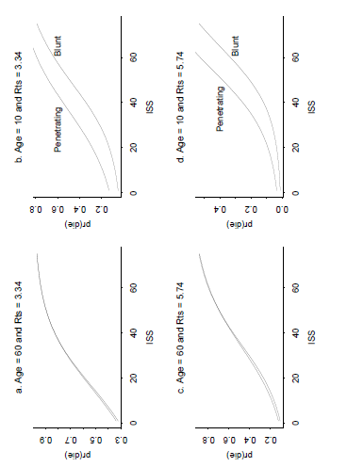

***Part (b):* Uniform (U(0, 1)) priors on tildeθ4, tildeθ5, tildeθ6**

|  |  |  |  |  |  |  |  |  |  |  |
| --- | --- | --- | --- | --- | --- | --- | --- | --- | --- | --- |
|  |  |  |  |  |  |  | Part(a) Priors = Beta | | Part(b) Priors = Unif. | |
| ID | ISS | RTS | AGE | TI | | node | mean | sd | mean | sd |
| 1 | 20 | 3.34 | 10 | 0 | | tildeath[1] | 0.1341 | 0.3408 | 0.1129 | 0.3165 |
| 2 | 40 | 3.34 | 10 | 0 | | tildeath[2] | 0.3511 | 0.4773 | 0.3804 | 0.4855 |
| 3 | 20 | 3.34 | 10 | 1 | | tildeath[3] | 0.2874 | 0.4525 | 0.3894 | 0.4876 |
| 4 | 40 | 3.34 | 10 | 1 | | tildeath[4] | 0.5502 | 0.4975 | 0.7212 | 0.4484 |
| 5 | 20 | 5.74 | 10 | 0 | | tildeath[5] | 0.0361 | 0.1865 | 0.03205 | 0.1761 |
| 6 | 40 | 5.74 | 10 | 0 | | tildeath[6] | 0.1201 | 0.325 | 0.1532 | 0.3602 |
| 7 | 20 | 5.74 | 10 | 1 | | tildeath[7] | 0.09544 | 0.2938 | 0.1528 | 0.3598 |
| 8 | 40 | 5.74 | 10 | 1 | | tildeath[8] | 0.2472 | 0.4314 | 0.4445 | 0.4969 |
| 9 | 20 | 3.34 | 60 | 0 | | tildeath[9] | 0.5815 | 0.4933 | 0.5488 | 0.4976 |
| 10 | 40 | 3.34 | 60 | 0 | | tildeath[10] | 0.8251 | 0.3799 | 0.8462 | 0.3608 |
| 11 | 20 | 3.34 | 60 | 1 | | tildeath[11] | 0.5759 | 0.4942 | 0.5783 | 0.4938 |
| 12 | 40 | 3.34 | 60 | 1 | | tildeath[12] | 0.8142 | 0.3889 | 0.8505 | 0.3566 |
| 13 | 20 | 5.74 | 60 | 0 | | tildeath[13] | 0.2586 | 0.4379 | 0.2517 | 0.434 |
| 14 | 40 | 5.74 | 60 | 0 | | tildeath[14] | 0.5478 | 0.4977 | 0.6137 | 0.4869 |
| 15 | 20 | 5.74 | 60 | 1 | | tildeath[15] | 0.2719 | 0.445 | 0.2961 | 0.4565 |
| 16 | 40 | 5.74 | 60 | 1 | | tildeath[16] | 0.5501 | 0.4975 | 0.6358 | 0.4812 |

|  |  |  |  |  |  |
| --- | --- | --- | --- | --- | --- |
|  |  | Part(a) Priors = Beta | | Part(b) Priors = Unif. | |
| node | Probability | mean | sd | mean | sd |
| prob[1] | Pr(γ1) > 0 | 0 | 0 | 0 | 0 |
| prob[2] | Pr(γ2) > 0 | 0.9992 | 0.02772 | 1 | 0 |
| prob[3] | Pr(γ3) > 0 | 5.13E-05 | 0.007161 | 5.13E-05 | 0.007161 |
| prob[4] | Pr(γ4) > 0 | 0.9997 | 0.01754 | 0.9996 | 0.01894 |
| prob[5] | Pr(γ5) > 0 | 0.8315 | 0.3743 | 0.9572 | 0.2023 |
| prob[6] | Pr(γ6) > 0 | 0.2557 | 0.4362 | 0.1569 | 0.3637 |

|  |  |  |  |  |  |  |  |  |  |
| --- | --- | --- | --- | --- | --- | --- | --- | --- | --- |
|  |  | Part(a) Priors = Beta | | | | Part(b) Priors = Unif. | | | |
| Combination ID | node | mean | 2.50% | median | 97.50% | mean | 2.50% | median | 97.50% |
| 1 | deathprob[1] | 0.133 | 0.048 | 0.125 | 0.271 | 0.117 | 0.036 | 0.109 | 0.247 |
| 2 | deathprob[2] | 0.346 | 0.165 | 0.336 | 0.583 | 0.384 | 0.180 | 0.379 | 0.618 |
| 3 | deathprob[3] | 0.288 | 0.053 | 0.258 | 0.683 | 0.387 | 0.096 | 0.370 | 0.762 |
| 4 | deathprob[4] | 0.550 | 0.193 | 0.559 | 0.869 | 0.720 | 0.359 | 0.748 | 0.944 |
| 5 | deathprob[5] | 0.035 | 0.012 | 0.033 | 0.074 | 0.034 | 0.011 | 0.031 | 0.073 |
| 6 | deathprob[6] | 0.119 | 0.039 | 0.108 | 0.260 | 0.150 | 0.049 | 0.139 | 0.311 |
| 7 | deathprob[7] | 0.092 | 0.017 | 0.077 | 0.254 | 0.153 | 0.037 | 0.135 | 0.369 |
| 8 | deathprob[8] | 0.252 | 0.066 | 0.233 | 0.543 | 0.447 | 0.149 | 0.441 | 0.780 |
| 9 | deathprob[9] | 0.582 | 0.297 | 0.588 | 0.836 | 0.546 | 0.252 | 0.550 | 0.818 |
| 10 | deathprob[10] | 0.823 | 0.615 | 0.839 | 0.949 | 0.844 | 0.640 | 0.861 | 0.959 |
| 11 | deathprob[11] | 0.574 | 0.242 | 0.578 | 0.873 | 0.577 | 0.210 | 0.590 | 0.891 |
| 12 | deathprob[12] | 0.815 | 0.576 | 0.832 | 0.957 | 0.851 | 0.594 | 0.876 | 0.978 |
| 13 | deathprob[13] | 0.262 | 0.127 | 0.257 | 0.430 | 0.253 | 0.118 | 0.246 | 0.424 |
| 14 | deathprob[14] | 0.551 | 0.307 | 0.555 | 0.779 | 0.615 | 0.364 | 0.622 | 0.824 |
| 15 | deathprob[15] | 0.271 | 0.074 | 0.251 | 0.569 | 0.297 | 0.072 | 0.277 | 0.645 |
| 16 | deathprob[16] | 0.543 | 0.224 | 0.549 | 0.837 | 0.635 | 0.269 | 0.651 | 0.918 |

***Part (c):* Using full priors from Table8.5 (untransformed covariates)**

Using R first we need to get **Xtinv**

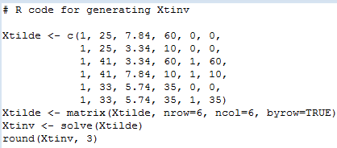

Output from R:

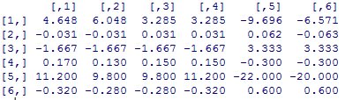

Modified WinBUGS code to handle untransformed covariates:

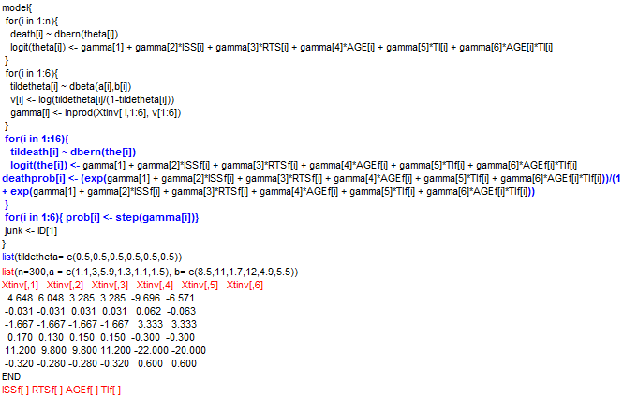

Results:

|  |  |  |  |  |  |  |  |  |  |
| --- | --- | --- | --- | --- | --- | --- | --- | --- | --- |
|  |  | Part(a) | | | | Part(c) | | | |
| Combination ID | node | mean | 2.50% | median | 97.50% | mean | 2.50% | median | 97.50% |
| 1 | deathprob[1] | 0.133 | 0.048 | 0.125 | 0.271 | 0.131 | 0.042 | 0.120 | 0.271 |
| 2 | deathprob[2] | 0.346 | 0.165 | 0.336 | 0.583 | 0.334 | 0.149 | 0.327 | 0.550 |
| 3 | deathprob[3] | 0.288 | 0.053 | 0.258 | 0.683 | 0.291 | 0.060 | 0.259 | 0.680 |
| 4 | deathprob[4] | 0.550 | 0.193 | 0.559 | 0.869 | 0.551 | 0.215 | 0.556 | 0.863 |
| 5 | deathprob[5] | 0.035 | 0.012 | 0.033 | 0.074 | 0.035 | 0.012 | 0.032 | 0.074 |
| 6 | deathprob[6] | 0.119 | 0.039 | 0.108 | 0.260 | 0.114 | 0.037 | 0.106 | 0.241 |
| 7 | deathprob[7] | 0.092 | 0.017 | 0.077 | 0.254 | 0.094 | 0.021 | 0.078 | 0.250 |
| 8 | deathprob[8] | 0.252 | 0.066 | 0.233 | 0.543 | 0.252 | 0.076 | 0.235 | 0.517 |
| 9 | deathprob[9] | 0.582 | 0.297 | 0.588 | 0.836 | 0.581 | 0.288 | 0.589 | 0.839 |
| 10 | deathprob[10] | 0.823 | 0.615 | 0.839 | 0.949 | 0.820 | 0.607 | 0.835 | 0.948 |
| 11 | deathprob[11] | 0.574 | 0.242 | 0.578 | 0.873 | 0.565 | 0.250 | 0.569 | 0.863 |
| 12 | deathprob[12] | 0.815 | 0.576 | 0.832 | 0.957 | 0.807 | 0.590 | 0.825 | 0.950 |
| 13 | deathprob[13] | 0.262 | 0.127 | 0.257 | 0.430 | 0.264 | 0.130 | 0.258 | 0.433 |
| 14 | deathprob[14] | 0.551 | 0.307 | 0.555 | 0.779 | 0.549 | 0.314 | 0.555 | 0.760 |
| 15 | deathprob[15] | 0.271 | 0.074 | 0.251 | 0.569 | 0.265 | 0.077 | 0.246 | 0.562 |
| 16 | deathprob[16] | 0.543 | 0.224 | 0.549 | 0.837 | 0.532 | 0.225 | 0.535 | 0.829 |

|  |  |  |  |  |  |
| --- | --- | --- | --- | --- | --- |
|  |  | Part(a) | | Part(C) | |
| node | Probability | mean | sd | mean | sd |
| prob[1] | Pr(γ1) > 0 | 0 | 0 | 0.06677 | 0.2496 |
| prob[2] | Pr(γ2) > 0 | 0.9992 | 0.02772 | 0.9993 | 0.02678 |
| prob[3] | Pr(γ3) > 0 | 5.13E-05 | 0.00716 | 0.00E+00 | 0 |
| prob[4] | Pr(γ4) > 0 | 0.9997 | 0.01754 | 0.9995 | 0.02148 |
| prob[5] | Pr(γ5) > 0 | 0.8315 | 0.3743 | 0.8584 | 0.3486 |
| prob[6] | Pr(γ6) > 0 | 0.2557 | 0.4362 | 0.2305 | 0.4212 |

|  |  |  |  |  |  |  |  |  |  |
| --- | --- | --- | --- | --- | --- | --- | --- | --- | --- |
|  |  |  |  |  |  | Part(a) | | Part(c) | |
| ID | ISS | RTS | AGE | TI | node | mean | sd | mean | sd |
| 1 | 20 | 3.34 | 10 | 0 | tildeath[1] | 0.1341 | 0.3408 | 0.1290 | 0.3352 |
| 2 | 40 | 3.34 | 10 | 0 | tildeath[2] | 0.3511 | 0.4773 | 0.3368 | 0.4726 |
| 3 | 20 | 3.34 | 10 | 1 | tildeath[3] | 0.2874 | 0.4525 | 0.2873 | 0.4525 |
| 4 | 40 | 3.34 | 10 | 1 | tildeath[4] | 0.5502 | 0.4975 | 0.5470 | 0.4978 |
| 5 | 20 | 5.74 | 10 | 0 | tildeath[5] | 0.0361 | 0.1865 | 0.0355 | 0.1851 |
| 6 | 40 | 5.74 | 10 | 0 | tildeath[6] | 0.1201 | 0.325 | 0.1152 | 0.3192 |
| 7 | 20 | 5.74 | 10 | 1 | tildeath[7] | 0.09544 | 0.2938 | 0.0904 | 0.2868 |
| 8 | 40 | 5.74 | 10 | 1 | tildeath[8] | 0.2472 | 0.4314 | 0.2612 | 0.4393 |
| 9 | 20 | 3.34 | 60 | 0 | tildeath[9] | 0.5815 | 0.4933 | 0.5838 | 0.4929 |
| 10 | 40 | 3.34 | 60 | 0 | tildeath[10] | 0.8251 | 0.3799 | 0.8226 | 0.3820 |
| 11 | 20 | 3.34 | 60 | 1 | tildeath[11] | 0.5759 | 0.4942 | 0.5610 | 0.4963 |
| 12 | 40 | 3.34 | 60 | 1 | tildeath[12] | 0.8142 | 0.3889 | 0.8086 | 0.3934 |
| 13 | 20 | 5.74 | 60 | 0 | tildeath[13] | 0.2586 | 0.4379 | 0.2623 | 0.4399 |
| 14 | 40 | 5.74 | 60 | 0 | tildeath[14] | 0.5478 | 0.4977 | 0.5491 | 0.4976 |
| 15 | 20 | 5.74 | 60 | 1 | tildeath[15] | 0.2719 | 0.445 | 0.2675 | 0.4426 |
| 16 | 40 | 5.74 | 60 | 1 | tildeath[16] | 0.5501 | 0.4975 | 0.5275 | 0.4992 |

***Exercise 8.14 Part(a)***

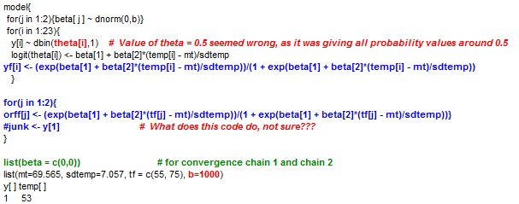

**Values of b (precision) I used:**

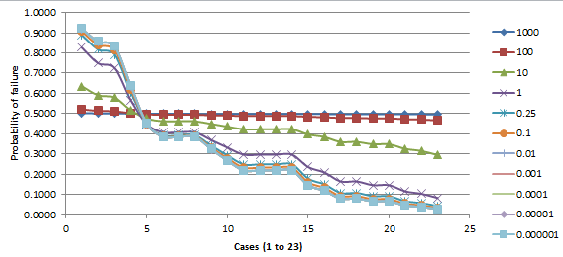

Based on the plot above ***b = 1000*** (low variance) gives the most uniform priors on the theta’s.

***Part(b)***

The table below shows the probability of O-ring failures when b = 1000, b = 0.25, and b = 0.000001S

|  |  |  |  |  |  |  |
| --- | --- | --- | --- | --- | --- | --- |
| B | 1000 | | 0.25 | | 0.000001 | |
| node | mean | sd | mean | sd | mean | sd |
| yf[1] | 0.5024 | 0.0199 | 0.8893 | 0.1305 | 0.9199 | 0.1145 |
| yf[2] | 0.5016 | 0.0160 | 0.8176 | 0.1516 | 0.8568 | 0.1428 |
| yf[3] | 0.5014 | 0.0150 | 0.7923 | 0.1562 | 0.8331 | 0.1503 |
| yf[4] | 0.5003 | 0.0107 | 0.6044 | 0.1588 | 0.6364 | 0.1706 |
| yf[5] | 0.4996 | 0.0088 | 0.4467 | 0.1345 | 0.4507 | 0.1473 |
| yf[6] | 0.4994 | 0.0083 | 0.3926 | 0.1240 | 0.3854 | 0.1343 |
| yf[7] | 0.4994 | 0.0083 | 0.3926 | 0.1240 | 0.3854 | 0.1343 |
| yf[8] | 0.4994 | 0.0083 | 0.3926 | 0.1240 | 0.3854 | 0.1343 |
| yf[9] | 0.4992 | 0.0080 | 0.3407 | 0.1142 | 0.3234 | 0.1217 |
| yf[10] | 0.4990 | 0.0079 | 0.2925 | 0.1057 | 0.2674 | 0.1107 |
| yf[11] | 0.4988 | 0.0079 | 0.2491 | 0.0988 | 0.2191 | 0.1015 |
| yf[12] | 0.4988 | 0.0079 | 0.2491 | 0.0988 | 0.2191 | 0.1015 |
| yf[13] | 0.4988 | 0.0079 | 0.2491 | 0.0988 | 0.2191 | 0.1015 |
| yf[14] | 0.4988 | 0.0079 | 0.2491 | 0.0988 | 0.2191 | 0.1015 |
| yf[15] | 0.4984 | 0.0083 | 0.1785 | 0.0883 | 0.1456 | 0.0867 |
| yf[16] | 0.4982 | 0.0088 | 0.1508 | 0.0839 | 0.1189 | 0.0802 |
| yf[17] | 0.4977 | 0.0100 | 0.1082 | 0.0754 | 0.0802 | 0.0683 |
| yf[18] | 0.4977 | 0.0100 | 0.1082 | 0.0754 | 0.0802 | 0.0683 |
| yf[19] | 0.4975 | 0.0107 | 0.0921 | 0.0714 | 0.0664 | 0.0630 |
| yf[20] | 0.4975 | 0.0107 | 0.0921 | 0.0714 | 0.0664 | 0.0630 |
| yf[21] | 0.4971 | 0.0123 | 0.0674 | 0.0638 | 0.0463 | 0.0538 |
| yf[22] | 0.4969 | 0.0132 | 0.0581 | 0.0603 | 0.0391 | 0.0499 |
| yf[23] | 0.4965 | 0.0150 | 0.0437 | 0.0542 | 0.0283 | 0.0433 |

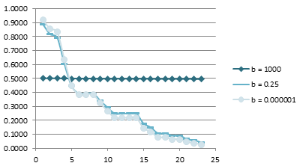

|  |  |  |  |  |  |  |
| --- | --- | --- | --- | --- | --- | --- |
| B | node | mean | sd | 2.50% | median | 97.50% |
| 1000 | beta[1] | -0.0044 | 0.0315 | -0.0657 | -0.0044 | 0.0572 |
| beta[2] | -0.0060 | 0.0314 | -0.0678 | -0.0057 | 0.0550 |
| 0.25 | beta[1] | -1.0770 | 0.5560 | -2.2310 | -1.0540 | -0.0482 |
| beta[2] | -1.6780 | 0.7101 | -3.2300 | -1.6170 | -0.4627 |
| 0.000001 | beta[1] | -1.2570 | 0.6365 | -2.605 | -1.22 | -0.1162 |
| beta[2] | -2.0640 | 0.9084 | -4.15 | -1.95 | -0.6078 |

***Estimates of probability of O-ring failure at 55 and 75 degrees***

|  |  |  |  |  |  |  |
| --- | --- | --- | --- | --- | --- | --- |
| B | node | mean | sd | 2.50% | median | 97.50% |
| 1000 | orff[55] | 0.5020 | 0.0179 | 0.4672 | 0.5019 | 0.5372 |
| orff[75] | 0.4977 | 0.0100 | 0.4782 | 0.4977 | 0.5172 |
| 0.25 | orff[55] | 0.8586 | 0.1412 | 0.4738 | 0.9060 | 0.9961 |
| orff[75] | 0.1082 | 0.0754 | 0.0142 | 0.0908 | 0.2978 |
| 0.000001 | orff[55] | 0.8937 | 0.1280 | 0.5277 | 0.943 | 0.9991 |
| orff[75] | 0.0802 | 0.0683 | 0.005068 | 0.06115 | 0.2596 |

***Convergence***

***b = 1000***

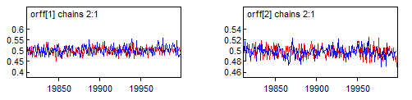

***b = 0.25***

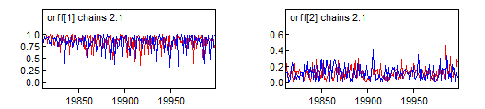

***b = 0.000001***

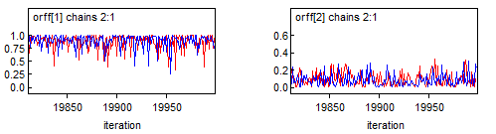

***Exercise 8.17***

***The code below do not seem to work, gives me error “Trap 0”***

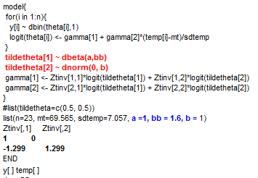

***Part(b)*** *let b = 0.001 and reanalyze data. The code below also does not work, give me error “Trap 0”*

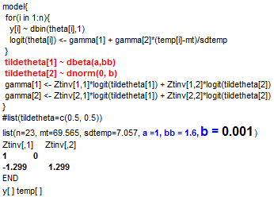

***Part(c)*** tildeX1 = 55, tildeX2 = 75, (i) tildetheta[1] ~ beta(1.6, 1), tildetheta[2 ] ~ beta(1,1)

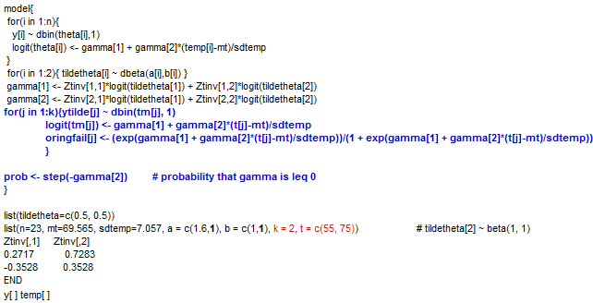

***Results***

|  |  |  |  |  |  |  |  |  |
| --- | --- | --- | --- | --- | --- | --- | --- | --- |
| **node** | **mean** | **sd** | **MC error** | **2.50%** | **median** | **97.50%** | **start** | **sample** |
| P55 | 0.7703 | 0.1501 | 6.80E-04 | 0.4122 | 0.7994 | 0.9735 | 501 | 99500 |
| P75 | 0.153 | 0.08497 | 3.48E-04 | 0.03131 | 0.1387 | 0.354 | 501 | 99500 |
| gamma[1] | -0.9733 | 0.5063 | 0.001641 | -2.034 | -0.9491 | -0.04451 | 501 | 99500 |
| gamma[2] | -1.173 | 0.4998 | 0.002184 | -2.263 | -1.139 | -0.2911 | 501 | 99500 |
| tildetheta[1] | 0.7704 | 0.15 | 6.80E-04 | 0.4122 | 0.7995 | 0.9735 | 501 | 99500 |
| tildetheta[2] | 0.153 | 0.08497 | 3.48E-04 | 0.03131 | 0.1387 | 0.354 | 501 | 99500 |
| P(γ2) < 0 | 0.9969 | 0.056 | 1.88E-04 | 1 | 1 | 1 | 501 | 99500 |

(ii) tildetheta[1] ~ beta(0.5, 0.5), tildetheta[2 ] ~ beta(1,1.6)

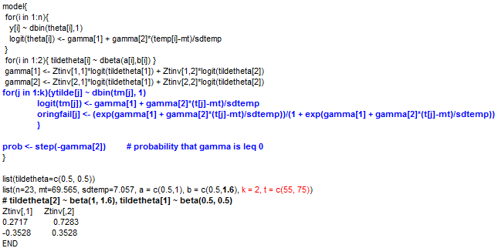

***Results***

|  |  |  |  |  |  |  |  |  |
| --- | --- | --- | --- | --- | --- | --- | --- | --- |
| **node** | **mean** | **sd** | **MC error** | **2.50%** | **median** | **97.50%** | **start** | **sample** |
| P55 | 0.7959 | 0.1585 | 7.77E-04 | 0.401 | 0.8355 | 0.9869 | 501 | 99500 |
| P75 | 0.1416 | 0.08238 | 3.57E-04 | 0.0266 | 0.1265 | 0.3388 | 501 | 99500 |
| gamma[1] | -0.9792 | 0.514 | 0.00154 | -2.044 | -0.9594 | -0.02501 | 501 | 99500 |
| gamma[2] | -1.305 | 0.5797 | 0.002907 | -2.578 | -1.258 | -0.2959 | 501 | 99500 |
| tildetheta[1] | 0.7959 | 0.1585 | 7.77E-04 | 0.401 | 0.8356 | 0.987 | 501 | 99500 |
| tildetheta[2] | 0.1416 | 0.08238 | 3.57E-04 | 0.0266 | 0.1265 | 0.3388 | 501 | 99500 |
| P(γ2) < 0 | 0.9957 | 0.06522 | 2.48E-04 | 1 | 1 | 1 | 501 | 99500 |

***Exercise 8.18***

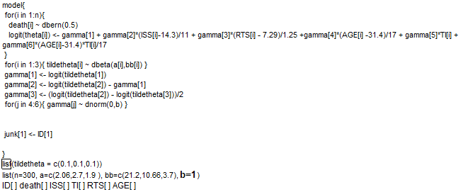

**Value of b that seems least informative = 1**

|  |  |  |  |  |  |  |
| --- | --- | --- | --- | --- | --- | --- |
|  | **node** | **mean** | **2.50%** | **median** | **97.50%** | **sample** |
| **b=1** | gamma[1] | -2.56800 | -4.402 | -2.482 | -1.216 | 100000 |
| gamma[2] | 1.04500 | -1.070 | 1.026 | 3.289 | 100000 |
| gamma[3] | -0.35460 | -1.551 | -0.362 | 0.892 | 100000 |
| gamma[4] | 0.00168 | -1.961 | 0.005 | 1.973 | 100000 |
| gamma[5] | 0.00037 | -1.965 | 0.003 | 1.948 | 100000 |
| gamma[6] | -0.00002 | -1.967 | 0.003 | 1.951 | 100000 |

**Different Values of b that were used**

|  |  |  |  |  |  |  |
| --- | --- | --- | --- | --- | --- | --- |
|  | **node** | **mean** | **2.50%** | **median** | **97.50%** | **sample** |
| **b=0.01** | gamma[4] | 0.017 | -19.610 | 0.049 | 19.730 | 100000 |
| gamma[5] | 0.004 | -19.650 | 0.032 | 19.480 | 100000 |
| gamma[6] | 0.000 | -19.670 | 0.027 | 19.510 | 100000 |
| **b=0.1** | gamma[4] | 0.005308 | -6.200 | 0.016 | 6.241 | 100000 |
| gamma[5] | 0.001164 | -6.215 | 0.010 | 6.160 | 100000 |
| gamma[6] | -0.000079 | -6.219 | 0.008 | 6.168 | 100000 |
| **b=1** | gamma[4] | 0.001679 | -1.961 | 0.005 | 1.973 | 100000 |
| gamma[5] | 0.000368 | -1.965 | 0.003 | 1.948 | 100000 |
| gamma[6] | -0.000025 | -1.967 | 0.003 | 1.951 | 100000 |
| **b=10** | gamma[4] | 5.31E-04 | -0.620 | 0.002 | 0.624 | 100000 |
| gamma[5] | 1.16E-04 | -0.622 | 0.001 | 0.616 | 100000 |
| gamma[6] | -7.85E-06 | -0.622 | 0.001 | 0.617 | 100000 |

***Exercise 8.19***

*Running the modified code and* ***b*** *from exercise 8.18 (****b = 1)***

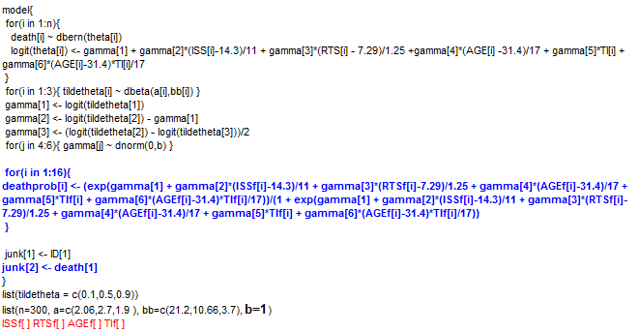

**Result:**

|  |  |  |  |  |  |
| --- | --- | --- | --- | --- | --- |
| node | mean | 2.50% | median | 97.50% | sample |
| deathprob[1] | 0.1639 | 0.0441 | 0.1470 | 0.3722 | 19500 |
| deathprob[2] | 0.4359 | 0.1902 | 0.4306 | 0.7062 | 19500 |
| deathprob[3] | 0.2319 | 0.0377 | 0.2018 | 0.5803 | 19500 |
| deathprob[4] | 0.5200 | 0.1440 | 0.5277 | 0.8680 | 19500 |
| deathprob[5] | 0.0513 | 0.0178 | 0.0470 | 0.1077 | 19500 |
| deathprob[6] | 0.1905 | 0.0677 | 0.1785 | 0.3796 | 19500 |
| deathprob[7] | 0.0833 | 0.0131 | 0.0679 | 0.2402 | 19500 |
| deathprob[8] | 0.2694 | 0.0467 | 0.2423 | 0.6307 | 19500 |
| deathprob[9] | 0.5679 | 0.2745 | 0.5740 | 0.8275 | 19500 |
| deathprob[10] | 0.8382 | 0.6297 | 0.8548 | 0.9573 | 19500 |
| deathprob[11] | 0.6500 | 0.1831 | 0.6862 | 0.9404 | 19500 |
| deathprob[12] | 0.8596 | 0.4724 | 0.9052 | 0.9884 | 19500 |
| deathprob[13] | 0.2848 | 0.1431 | 0.2780 | 0.4589 | 19500 |
| deathprob[14] | 0.6207 | 0.3574 | 0.6294 | 0.8382 | 19500 |
| deathprob[15] | 0.3981 | 0.0735 | 0.3887 | 0.7708 | 19500 |
| deathprob[16] | 0.6896 | 0.2172 | 0.7346 | 0.9554 | 19500 |

***Running “dflat” priors for all beta(j)’s****:*

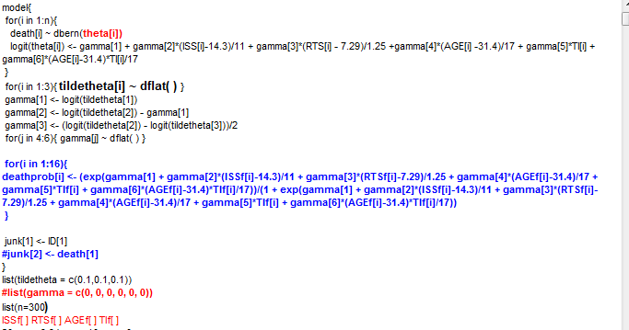

*When I run the above code I get error called “****Trap 0****” so I am unable to proceed, below is the code I used instead:*

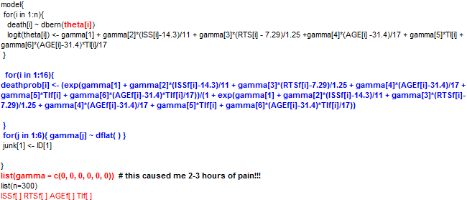

|  |  |  |  |  |  |
| --- | --- | --- | --- | --- | --- |
| node | mean | 2.50% | median | 97.50% | sample |
| deathprob[1] | 0.095 | 0.015 | 0.077 | 0.274 | 20000 |
| deathprob[2] | 0.332 | 0.100 | 0.317 | 0.643 | 20000 |
| deathprob[3] | 0.287 | 0.038 | 0.254 | 0.697 | 20000 |
| deathprob[4] | 0.625 | 0.168 | 0.655 | 0.936 | 20000 |
| deathprob[5] | 0.024 | 0.005 | 0.020 | 0.065 | 20000 |
| deathprob[6] | 0.116 | 0.027 | 0.102 | 0.285 | 20000 |
| deathprob[7] | 0.097 | 0.011 | 0.078 | 0.295 | 20000 |
| deathprob[8] | 0.345 | 0.049 | 0.320 | 0.760 | 20000 |
| deathprob[9] | 0.573 | 0.251 | 0.581 | 0.857 | 20000 |
| deathprob[10] | 0.866 | 0.652 | 0.885 | 0.974 | 20000 |
| deathprob[11] | 0.724 | 0.191 | 0.783 | 0.974 | 20000 |
| deathprob[12] | 0.906 | 0.514 | 0.952 | 0.997 | 20000 |
| deathprob[13] | 0.262 | 0.116 | 0.254 | 0.452 | 20000 |
| deathprob[14] | 0.644 | 0.356 | 0.657 | 0.872 | 20000 |
| deathprob[15] | 0.469 | 0.068 | 0.476 | 0.857 | 20000 |
| deathprob[16] | 0.766 | 0.222 | 0.830 | 0.983 | 20000 |

*However the code below (partial prior with dflat does not work)*

***Running “dflat”* priors on tildeθ4, tildeθ5, tildeθ6**

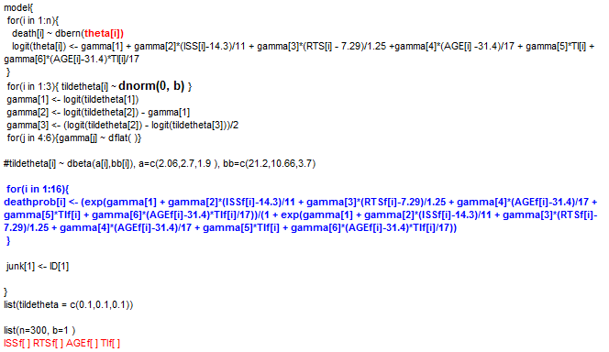

***The above code doesn’t seem to work, I get “Trap 0” error.***

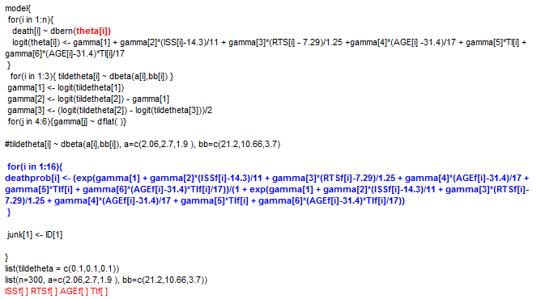

***The above code also doesn’t seem to work, I get “Trap 0” error.***

***Part (b):* Modify code from 8.11 and Uniform (U(0, 1)) priors on tildeθ4, tildeθ5, tildeθ6**

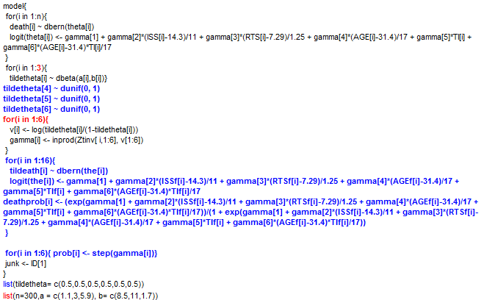

**Result:**

|  |  |  |  |  |  |
| --- | --- | --- | --- | --- | --- |
| Combination ID | node | mean | 2.50% | median | 97.50% |
| 1 | deathprob[1] | 0.117 | 0.036 | 0.109 | 0.247 |
| 2 | deathprob[2] | 0.384 | 0.18 | 0.379 | 0.618 |
| 3 | deathprob[3] | 0.387 | 0.096 | 0.37 | 0.762 |
| 4 | deathprob[4] | 0.72 | 0.359 | 0.748 | 0.944 |
| 5 | deathprob[5] | 0.034 | 0.011 | 0.031 | 0.073 |
| 6 | deathprob[6] | 0.15 | 0.049 | 0.139 | 0.311 |
| 7 | deathprob[7] | 0.153 | 0.037 | 0.135 | 0.369 |
| 8 | deathprob[8] | 0.447 | 0.149 | 0.441 | 0.78 |
| 9 | deathprob[9] | 0.546 | 0.252 | 0.55 | 0.818 |
| 10 | deathprob[10] | 0.844 | 0.64 | 0.861 | 0.959 |
| 11 | deathprob[11] | 0.577 | 0.21 | 0.59 | 0.891 |
| 12 | deathprob[12] | 0.851 | 0.594 | 0.876 | 0.978 |
| 13 | deathprob[13] | 0.253 | 0.118 | 0.246 | 0.424 |
| 14 | deathprob[14] | 0.615 | 0.364 | 0.622 | 0.824 |
| 15 | deathprob[15] | 0.297 | 0.072 | 0.277 | 0.645 |
| 16 | deathprob[16] | 0.635 | 0.269 | 0.651 | 0.918 |

***Exercise 8.21***

**A)** Results from running the code given (Ran 1000 iterations as it takes ~10 minutes)

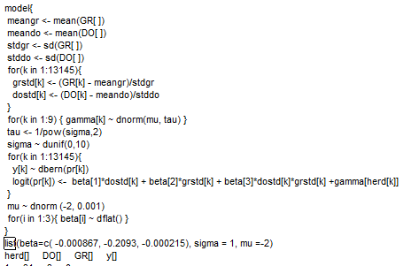

|  |  |  |  |  |  |  |
| --- | --- | --- | --- | --- | --- | --- |
| **node** | **mean** | **sd** | **MC error** | **2.50%** | **median** | **97.50%** |
| beta[1] | 0.0342 | 0.0254 | 0.0012 | -0.0215 | 0.0347 | 0.0830 |
| beta[2] | 0.0334 | 0.0259 | 0.0012 | -0.0172 | 0.0336 | 0.0839 |
| beta[3] | -0.0667 | 0.0247 | 0.0013 | -0.1177 | -0.0668 | -0.0191 |
| gamma[1] | -1.7470 | 0.0720 | 0.0040 | -1.9070 | -1.7410 | -1.6170 |
| gamma[2] | -1.8910 | 0.0630 | 0.0021 | -2.0050 | -1.8940 | -1.7650 |
| gamma[3] | -1.4640 | 0.0864 | 0.0038 | -1.6190 | -1.4660 | -1.2980 |
| gamma[4] | -1.6360 | 0.0776 | 0.0030 | -1.7820 | -1.6420 | -1.4780 |
| gamma[5] | -1.9890 | 0.0740 | 0.0035 | -2.1360 | -1.9900 | -1.8410 |
| gamma[6] | -2.2930 | 0.0910 | 0.0045 | -2.4860 | -2.2890 | -2.1350 |
| gamma[7] | -1.6660 | 0.0545 | 0.0032 | -1.7750 | -1.6640 | -1.5620 |
| gamma[8] | -2.0840 | 0.0772 | 0.0037 | -2.2380 | -2.0810 | -1.9350 |
| gamma[9] | -1.6900 | 0.2108 | 0.0106 | -2.1420 | -1.6780 | -1.2650 |

**B)** Results from running the modified code with random effects centered at zero and intercept included. (Ran 1000 iterations as it takes ~10 minutes)

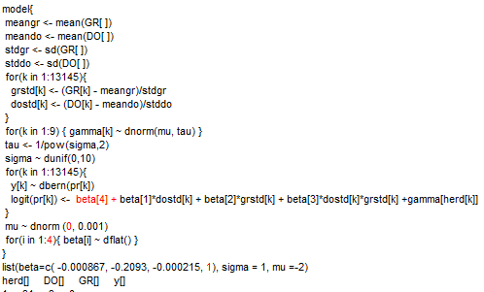

|  |  |  |  |  |  |  |
| --- | --- | --- | --- | --- | --- | --- |
| **node** | **mean** | **sd** | **MC error** | **2.50%** | **median** | **97.50%** |
| beta[1] | 0.0344 | 0.0256 | 0.0011 | -0.0155 | 0.0361 | 0.0800 |
| beta[2] | 0.0334 | 0.0245 | 0.0010 | -0.0161 | 0.0331 | 0.0822 |
| beta[3] | -0.0678 | 0.0250 | 0.0011 | -0.1150 | -0.0675 | -0.0185 |
| beta[4] | -0.8480 | 0.2044 | 0.0412 | -1.1950 | -0.8524 | -0.3983 |
| gamma[1] | -0.8909 | 0.2168 | 0.0415 | -1.3330 | -0.8805 | -0.4939 |
| gamma[2] | -1.0470 | 0.2150 | 0.0414 | -1.5220 | -1.0330 | -0.6890 |
| gamma[3] | -0.6158 | 0.2202 | 0.0417 | -1.0240 | -0.6184 | -0.2110 |
| gamma[4] | -0.7816 | 0.2214 | 0.0426 | -1.2500 | -0.7752 | -0.4041 |
| gamma[5] | -1.1370 | 0.2139 | 0.0413 | -1.5690 | -1.1320 | -0.7534 |
| gamma[6] | -1.4470 | 0.2261 | 0.0424 | -1.9200 | -1.4250 | -1.0350 |
| gamma[7] | -0.8155 | 0.2075 | 0.0412 | -1.2460 | -0.8116 | -0.4412 |
| gamma[8] | -1.2350 | 0.2192 | 0.0421 | -1.7030 | -1.2250 | -0.8513 |
| gamma[9] | -0.8413 | 0.2916 | 0.0429 | -1.4350 | -0.8419 | -0.2538 |

**C)** Gamma distribution for sigma: **σ ~ gamma(0.0001, 10)** -> *This distribution incorporates Dr.Thurmond’s best guess for sigma as 0.25 and this distribution has scale parameter =10, not overly diffused.*

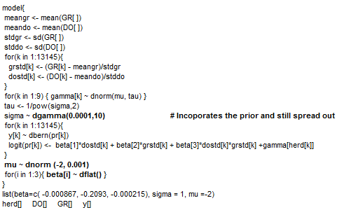

|  |  |  |  |  |  |  |
| --- | --- | --- | --- | --- | --- | --- |
| **node** | **mean** | **sd** | **MC error** | **2.50%** | **median** | **97.50%** |
| beta[1] | 0.03526 | 0.0247 | 0.001301 | -0.01607 | 0.03648 | 0.08184 |
| beta[2] | 0.03528 | 0.02486 | 0.001119 | -0.01439 | 0.03698 | 0.08046 |
| beta[3] | -0.06934 | 0.02407 | 8.93E-04 | -0.12 | -0.06801 | -0.02311 |
| gamma[1] | -1.748 | 0.06689 | 0.002844 | -1.874 | -1.748 | -1.622 |
| gamma[2] | -1.886 | 0.06306 | 0.002891 | -2.009 | -1.888 | -1.759 |
| gamma[3] | -1.483 | 0.08448 | 0.002796 | -1.648 | -1.479 | -1.326 |
| gamma[4] | -1.644 | 0.0763 | 0.003865 | -1.79 | -1.645 | -1.496 |
| gamma[5] | -1.987 | 0.07357 | 0.00342 | -2.127 | -1.985 | -1.849 |
| gamma[6] | -2.269 | 0.08956 | 0.004277 | -2.455 | -2.267 | -2.095 |
| gamma[7] | -1.667 | 0.05155 | 0.00207 | -1.768 | -1.667 | -1.565 |
| gamma[8] | -2.078 | 0.07137 | 0.001606 | -2.226 | -2.079 | -1.931 |
| gamma[9] | -1.71 | 0.1817 | 0.009551 | -2.049 | -1.707 | -1.343 |